Anti-Bullying Policy
POLICY STATEMENT:
The purpose of this policy is:
- To protect children young people, parents/carers and staff who attend Sparkles Academy of Performing Arts (SAPA
- To provide parents, staff and volunteers with the overarching principles that guide our approach to Anti-Bullying.
This policy applies to anyone working on behalf of Sparkles Academy of Performing Arts (SAPA), including senior managers, paid staff, volunteers, sessional workers, agency staff and students.
RELATED POLICIES AND PROCEDURES:
This policy should be read alongside our organisational policy procedures, including:
- Child Safeguarding Policy
- Managing allegations against staff and volunteers
- Recording information and sharing
- Code of conduct for staff and volunteers
- The use of social media
- Health and safety
ANTI-BULLYING:
WE SHALL ENDEAVOUR TO PROVIDE A SAFE ENVIRONMENT FOR ALL PUPILS, STAFF AND PARENTS/CARERS.

WE ENFORCE A STRICT ANTI SOCIAL BEHAVIOUR CODE OF PRACTICE - ANY MEMBER OF STAFF, PUPIL OR PARENT/CARER FOUND IN BREACH OF SUCH WILL BE EXCLUDED WITHOUT PRIOR NOTICE.

WE RESERVE THE RIGHT TO ADD TO THE FOLLOWING LIST AS WE DEEM NECESSARY.

BEHAVIOUR WHICH WILL UNRESERVEDLY BE DEEMED AS ANTI SOCIAL:
- AGGRESSIVE PHYSICAL CONTACT TOWARDS PUPILS, STAFF AND PARENTS/CARERS
- AGGRESSIVE VERBAL ABUSE TOWARDS PUPILS, STAFF AND PARENTS/CARERS
- SWEARING - VERBAL AND GESTICULAR
- UNKIND AND HURTFUL COMMENTS TOWARDS PUPILS, STAFF AND PARENTS/CARERS
- BULLYING OF ANY DESCRIPTION

We are committed to reviewing our policy and good practice annually.

This policy was last reviewed on 18/01/18

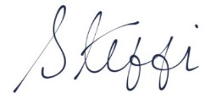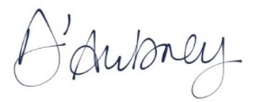

Steffi D’Aubney
Principal

