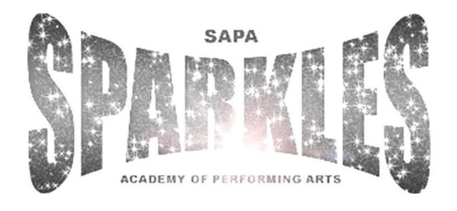

Complaints Procedure
Sparkles Academy of Performing Arts responds to all complaints and ensures that they are managed efficiently, courteously and as quickly as possible.
In the event of an Complainant being dissatisfied with the service provided or has a complaint about an individual, the complaint should first be made in writing to the Principal (Stephanie D’Aubney). If the complaint is about the Principal of Sparkles Academy of Performing Arts, the matter should be refered to the Manager of the Academy (Angelina D’Aubney). If a resolution cannot be met, an official complaint - in writing - will be escalated to the SAPA Committee sapacommittee@gmail.com
Complaints Procedure
- The complaint must be in writing; dated and signed by the complainant. Email complaints are acceptable, provided the complainant’s full name and postal address details are included.
- Anonymous complaints will not be considered or dealt with under this policy.
- The complaint must include the person(s) concerned, with a factual explanation of the context of the complaint. It must be accompanied by any supporting documentation and details of any action already taken to resolve the complaint.
- The complaint must not be submitted more than 2 months after the event/grievance had occurred; unless the complainant was not aware of said event or grievance at the time they occured.
- Sparkles Academy of Performing Arts will endeavour to acknowledge the complaint within 14 working days of receipt.
- All parties named in the complaint will be informed, whereby they will be instructed to provide their account of events; including any supporting evidence and documentation, unless there are exceptional circumstances for not providing the same. For example, the information would prejudice any criminal proceedings that may be instigated or are already in progress; or there are concerns about the safety of the Complainant or any third party.
- All complaints will be treated confidentially

